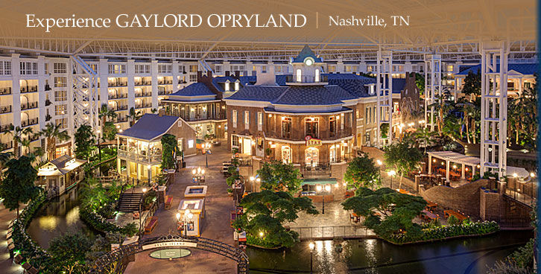

(Banner Image)

**Events & Conferences**

TSA members throughout the nation all agree that for them, the highlight of the school year is unquestionably the annual national conference. The TSA national conference is packed with competitive events and challenging activities that foster personal growth and leadership development. Each year TSA members are offered these and many more opportunities at the national conference.

**2015 TSA National Conference**

Gaylord Texan Resort & Convention Center, Dallas, TX

Conference Theme: “Designing Your Dreams”

June 28 – July 2, 2015

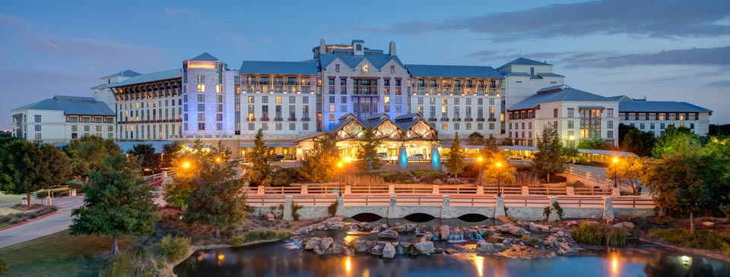

**2016 TSA Utah State Conference**

Davis Applied Technology College

550 East 300 South Kaysville, Utah

March 15-16, 2016

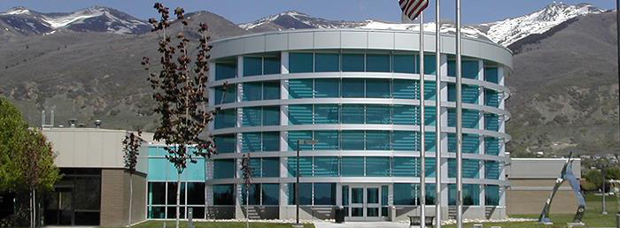

**2016 TSA National Conference**

Gaylord Opryland Resort & Convention Center, Nashville, TN

Conference Theme: “Building a Legacy”

June 28 – July 2, 2015

